Good Afternoon,

I am just letting you know we have had a transmitter and receiver stolen from one of our vehicles. Previously we have given the serial numbers to Nulca to either put on their website or keep a look out for any that become available for sale.

The details are:

Transmitter: RD4000 11/T10-1- 6313TN

Receiver: RD4000 11/4KRX - 15170PL

Kind Regards

Belinda

Reception

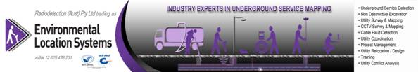

PO Box 2230 Fountain Gate VIC 3805  |  Fax: 03 8795 7491  |  <www.radiodetection.com.au>

**P: 03 8795 7461  |  M: 0414 352 472**